

Rosanna Cubs
Under the Ocean!

TUESDAY - 1st April!

Our final night for Term 1 is here! Time to let loose and have some fun!
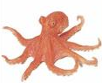
Come along and immerse yourself in ….. The Ocean
(well, not literally!)

Dress up as anything from under the sea – use your imagination to come along as a sea creature, sea monster, maybe part of a coral reef - who knows? Let’s see how imaginative you (and Mum or Dad!) can be. Just remember you need to be able to be mobile for our games and activities! Then, you can join in:


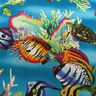
Under the Ocean!

TUESDAY, April 1st – BE THERE!


Regards

 |  | 
  Wayne Renfrew, Cub Scout Leader (Akela)
   | Rosanna Cub Scouts
  ph: | (03) 9434 7594 or 0411 121 495
  email: | akela@rosannacubs.org
  See us at: | www.rosannacubs.org

Excerpts from “Oceanology” by The Five Mile Press Pty Ltd
