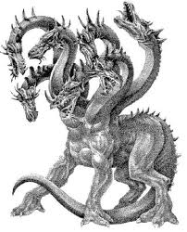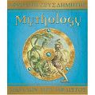Rosanna Cubs
MythOLOGY!

TUESDAY - 30th Mar!

Term 1 is almost over! Must be time for tons of fun!

Come along and immerse yourself in ….. MythologY

Dress up as a character from Greek Mythology (no, not yourself – you’re not a Greek God!) – use your imagination to come along as an Olympian God, Primordial God, Titan, Giant a Chthonic God, Sea God, Sky God or something else.... there’s thousands to choose from!

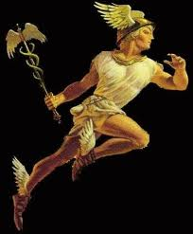Just remember you need to be mobile for our games and activities! Then, you can join in:
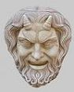 Mythology!

TUESDAY, MARCH 30th – BE THERE!

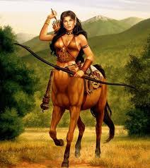Regards

Akela (Wayne)

akela@rosannacubs.org

0411 121 495

Excerpts from “Mythology” by The Five Mile Press Pty Ltd

