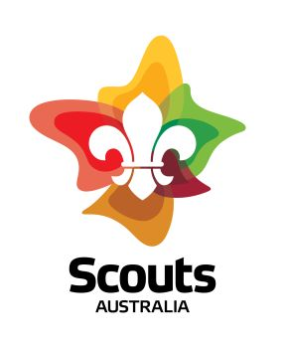
Rosanna Cubs
MonsterOLOGY!

TUESDAY - 17th Sep!

Who would have thought that Term 3 is almost over! Must be time for tons of fun!
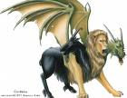
Come along and immerse yourself in ….. MonsterologY

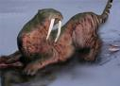
Dress up as a Monster (no, not yourself!) – but not just any monster – use your imagination to come along as a Fantastic Monster! What sort of monster? Maybe something like a Unicorn, a Chimera (you might need to grow 2 more heads!), a Yeti, a Kraken, Sea serpent, Mermaid, Bunyip, Griffin, Centaur, Phoenix, Cyclops or Sphinx (…OR any other Monster you can think of!). Just remember you need to be mobile for our games and activities! Then, you can join in:
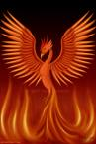
Monsterology!

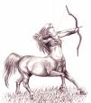
TUESDAY, SEPTEMBER 17th – BE THERE!

Regards
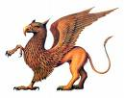

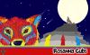 | Wayne Renfrew, Akela - Rosanna Cubs
 | ph: | (03) 9434 7594 or 0411 121 495
 | email: | akela@rosannacubs.org
 | See us at: | www.rosannacubs.org

Excerpts from “Monsterology” by The Five Mile Press Pty Ltd

